**Analysis 1 Report**

This dataset contains details of the used cars in Germany which are on sale on Ebay. This dataset is not clean and hence a lot of data cleaning should be carried out.

Then we will follow several steps for cleaning the dataset. Those are:

1. Check the missing values, if any missing values are there then replacing those missing values with appropriate values.

2. Check the datatype of columns, if datatype of columns is wrong then change the data type of it.

3. Check any wrong values are placed with in column, then remove those values from Column or replace with suitable value.

4. Finally check any duplicate values occur in dataset. Then remove those records from Dataset if it exists

5. Convert cleaned dataset into new csv file and save it in my folder.

**1.Perform general Data analysis**

Performing general data analysis involves several steps. Those are:

1.Reading file: - Obtain the dataset from a reliable source. This could be in the form of a CSV file. Read the file (data set)

2.Data Cleaning: - Check for missing values, inconsistencies in the data. - Handle missing data through imputation or removal. - Standardize data formats

3. Analysis: - using statistical measures and analyzing the data

**2.Can you tell me the Distribution of Vehicles based on Year of Registration with the help of a plot**

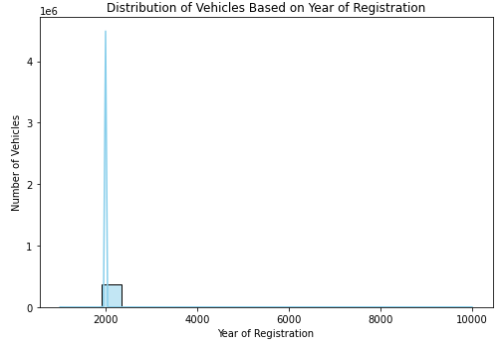

Based on the plot there are greater number of vehicles that are on sale in the year 2000.

**3.Create a plot based on the Variation of the price range by the vehicle type**

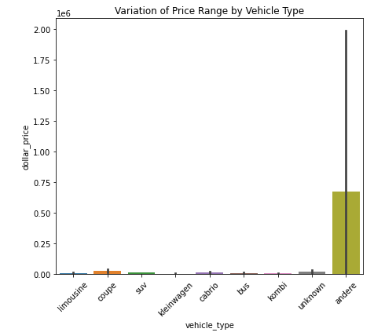

Based on this plot, Andere vehicle type has the highest price compared to other vehicle types.

Klein Wagen vehicle type has the lowest price range. Many peoples are willing to buy this type of vehicles.

**4. Find out Total count of vehicles by type available on Ebay for sale. As well as create a visualization for the client.**

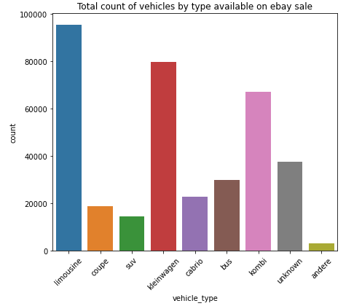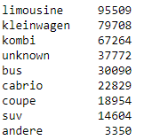

Based on the plot limousine is the most available vehicle type with highest vehicle count on Ebay for sale.

And Andere is the vehicle type which is less available in Ebay for sale.

**5. Is there any relationship between dollar price and kilometer? (Explain with appropriate analysis)**

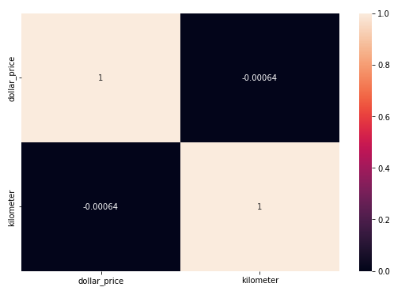

If the value is close to 0, it indicates no correlation. Here as the correlation value is -0.00064 and is nearly equal to 0 so there no relationship between dollar price and kilometer.